Konfigurasi Core Router

|  |  |
| --- | --- |
| Hostname | Core Router |
| IP Address | Fa0/0 192.168.1.1  Gig7/0 192.168.2.2  Gig9/0 192.168.7.1 |
| Subnet mask | 255.255.255.0 |
| Gateway | Fa0/0 192.168.1.1  Gig7/0 192.168.2.2  Gig9/0 192.168.7.1 |
| DNS Server | 192.168.9.53 |

Routing Table Core-Router

|  |  |  |  |  |
| --- | --- | --- | --- | --- |
| Network Destination | Netmask | Gateway | Interface | Metric |
| 192.168.3.0 | 255.255.255.0 | 192.168.2.4 | GigabitEthernet7/0 | 1 |
| 192.168.4.0 | 255.255.255.0 | 192.168.2.4 | GigabitEthernet7/0 | 1 |
| 192.168.5.0 | 255.255.255.0 | 192.168.2.4 | GigabitEthernet7/0 | 1 |
| 192.168.6.0 | 255.255.255.0 | 192.168.2.4 | GigabitEthernet7/0 | 1 |
| 192.168.9.0 | 255.255.255.0 | 192.168.7.2 | GigabitEthernet9/0 | 1 |

Konfigurasi Router 8

|  |  |
| --- | --- |
| Hostname | Router 8 |
| IP Address | Gig0/0/0 192.168.7.2  Gig0/0/1 192.168.9.1 |
| Subnet mask | 255.255.255.0 |
| Gateway | Gig0/0/0 192.168.7.1  Gig0/0/1 192.168.9.1 |
| DNS Server | 192.168.9.53 |

Routing Table Router 8

|  |  |  |  |  |
| --- | --- | --- | --- | --- |
| Network Destination | Netmask | Gateway | Interface | Metric |
| 192.168.1.0 | 255.255.255.0 | 192.168.7.1 | GigabitEthernet0/0/0 | 1 |
| 192.168.2.0 | 255.255.255.0 | 192.168.7.1 | GigabitEthernet0/0/0 | 1 |
| 192.168.3.0 | 255.255.255.0 | 192.168.7.1 | GigabitEthernet0/0/0 | 1 |
| 192.168.4.0 | 255.255.255.0 | 192.168.7.1 | GigabitEthernet0/0/0 | 1 |
| 192.168.5.0 | 255.255.255.0 | 192.168.7.1 | GigabitEthernet0/0/0 | 1 |
| 192.168.6.0 | 255.255.255.0 | 192.168.7.1 | GigabitEthernet0/0/0 | 1 |

Konfigurasi Distribution Router

|  |  |
| --- | --- |
| Hostname | Distribution Router |
| IP Address | Gig6/0 192.168.2.4  Fa0/0 192.168.3.2  Fa1/0 192.168.4.2 |
| Subnet mask | 255.255.255.0 |
| Gateway | Gig6/0 192.168.2.1  Fa0/0 192.168.3.2  Fa1/0 192.168.4.2 |
| DNS Server | 192.168.9.53 |

Routing Table Distribution Router

|  |  |  |  |  |
| --- | --- | --- | --- | --- |
| Network Destination | Netmask | Gateway | Interface | Metric |
| 192.168.1.0 | 255.255.255.0 | 192.168.2.2 | GigabitEthernet0/0/0 | 1 |
| 192.168.5.0 | 255.255.255.0 | 192.168.3.4 | FastEthernet0/0 | 1 |
| 192.168.6.0 | 255.255.255.0 | 192.168.4.4 | FastEthernet1/0 | 1 |
| 192.168.7.0 | 255.255.255.0 | 192.168.2.2 | GigabitEthernet6/0 | 1 |
| 192.168.9.0 | 255.255.255.0 | 192.168.2.2 | GigabitEthernet6/0 | 1 |

Konfigurasi Access Router A-1

|  |  |
| --- | --- |
| Hostname | Access Router A-1 |
| IP Address | Gig0/0 192.168.3.4  Gig0/1 192.168.5.1 |
| Subnet mask | 255.255.255.0 |
| Gateway | Gig0/0 192.168.3.2  Gig0/1 192.168.5.1 |
| DNS Server | 192.168.9.53 |

Routing Table Access Router A-1

|  |  |  |  |  |
| --- | --- | --- | --- | --- |
| Network Destination | Netmask | Gateway | Interface | Metric |
| 192.168.1.0 | 255.255.255.0 | 192.168.3.2 | GigabitEthernet0/0 | 1 |
| 192.168.2.0 | 255.255.255.0 | 192.168.3.2 | GigabitEthernet0/0 | 1 |
| 192.168.4.0 | 255.255.255.0 | 192.168.3.2 | GigabitEthernet0/0 | 1 |
| 192.168.6.0 | 255.255.255.0 | 192.168.3.2 | GigabitEthernet0/0 | 1 |
| 192.168.7.0 | 255.255.255.0 | 192.168.3.2 | GigabitEthernet0/0 | 1 |
| 192.168.9.0 | 255.255.255.0 | 192.168.3.2 | GigabitEthernet0/0 | 1 |

Konfigurasi Access Router A-2

|  |  |
| --- | --- |
| Hostname | Access Router A-2 |
| IP Address | Gig0/0 192.168.4.4  Gig0/1 192.168.6.1 |
| Subnet mask | 255.255.255.0 |
| Gateway | Gig0/0 192.168.4.2  Gig0/1 192.168.6.1 |
| DNS Server | 192.168.9.53 |

Routing Table Access Router A-2

|  |  |  |  |  |
| --- | --- | --- | --- | --- |
| Network Destination | Netmask | Gateway | Interface | Metric |
| 192.168.1.0 | 255.255.255.0 | 192.168.4.2 | GigabitEthernet0/0 | 1 |
| 192.168.2.0 | 255.255.255.0 | 192.168.4.2 | GigabitEthernet0/0 | 1 |
| 192.168.3.0 | 255.255.255.0 | 192.168.4.2 | GigabitEthernet0/0 | 1 |
| 192.168.5.0 | 255.255.255.0 | 192.168.4.2 | GigabitEthernet0/0 | 1 |
| 192.168.7.0 | 255.255.255.0 | 192.168.4.2 | GigabitEthernet0/0 | 1 |
| 192.168.9.0 | 255.255.255.0 | 192.168.4.2 | GigabitEthernet0/0 | 1 |

Konfigurasi Main Web Server

|  |  |
| --- | --- |
| Hostname | [www.jarkom.org](http://www.jarkom.org) |
| IP Address | 192.168.9.80 |
| Subnet mask | 255.255.255.0 |
| Gateway | 192.168.9.1 |
| DNS Server | 192.168.9.53 |

Konfigurasi DNS Server

|  |  |
| --- | --- |
| Hostname | ns.jarkom.org |
| IP Address | 192.168.9.53 |
| Subnet mask | 255.255.255.0 |
| Gateway | 192.168.9.1 |
| DNS Server | 192.168.9.53 |

Konfigurasi DHCP Server A-2

|  |  |
| --- | --- |
| Hostname | dhcp-a2.jarkom.org |
| IP Address | 192.168.6.5 |
| Subnet mask | 255.255.255.0 |
| Gateway | 192.168.6.1 |
| DNS Server | 192.168.9.53 |

Konfigurasi PC0

|  |  |
| --- | --- |
| Hostname | PC0 |
| IP Address | 192.168.5.3 |
| Subnet mask | 255.255.255.0 |
| Gateway | 192.168.5.1 |
| DNS Server | 192.168.9.53 |

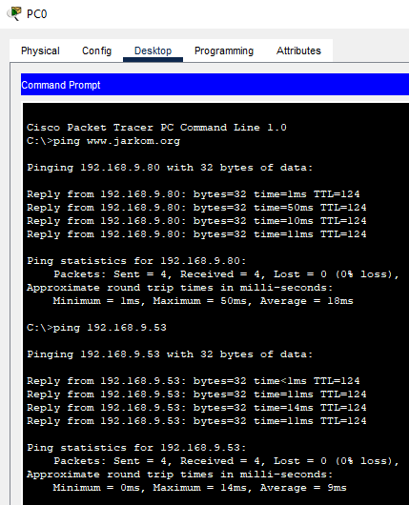

Konfigurasi PC1

|  |  |
| --- | --- |
| Hostname | PC1 |
| IP Address | 192.168.5.2 |
| Subnet mask | 255.255.255.0 |
| Gateway | 192.168.5.1 |
| DNS Server | 192.168.9.53 |

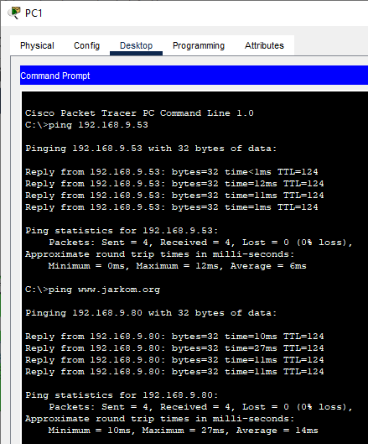

Konfigurasi PC0(2)

|  |  |
| --- | --- |
| Hostname | PC0(2) |
| IP Address | 192.168.6.3 |
| Subnet mask | 255.255.255.0 |
| Gateway | 192.168.6.1 |
| DNS Server | 192.168.9.53 |

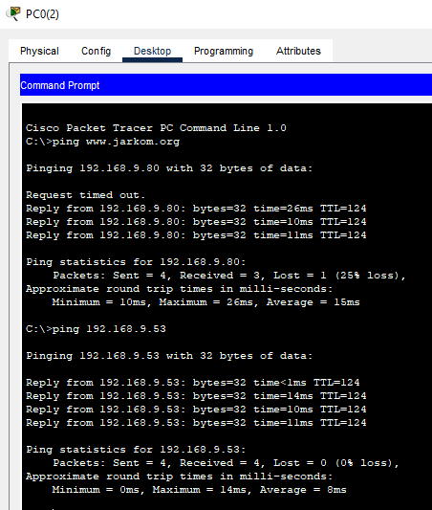

Konfigurasi PC1(2)

|  |  |
| --- | --- |
| Hostname | PC1(2) |
| IP Address | 192.168.6.2 |
| Subnet mask | 255.255.255.0 |
| Gateway | 192.168.6.1 |
| DNS Server | 192.168.9.53 |

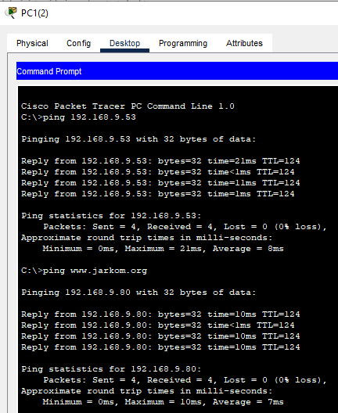

Konfigurasi AP-1

|  |  |
| --- | --- |
| Hostname | AP A-1 |
| IP Address | 192.168.5.1 |
| Subnet mask | 255.255.255.0 |
| Gateway | 192.168.5.1 |
| DNS Server | 192.168.9.53 |
| WLAN Security | WEP |
| SSID | AP A-1 |
| SSID Key | 2222222222 |

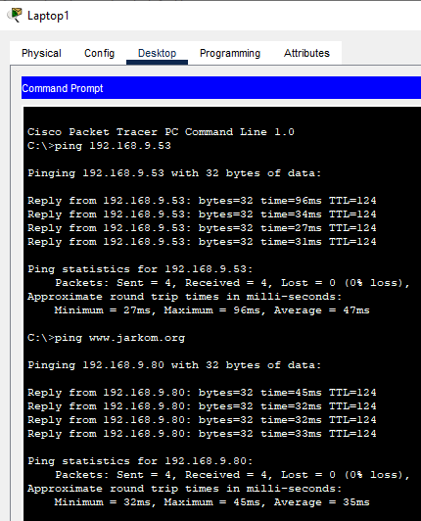

Konfigurasi AP-2

|  |  |
| --- | --- |
| Hostname | AP A-2 |
| IP Address | 192.168.6.1 |
| Subnet mask | 255.255.255.0 |
| Gateway | 192.168.1 |
| DNS Server | 192.168.9.53 |
| WLAN Security | WPA2-PSK |
| SSID | AP A-2 |
| SSID Key | 12345678 |

